|  |  |  |
| --- | --- | --- |
| **EX:1** | **Setting up the Python environment and libraries-Juypter Notebook** | **AD23632** |

**Aim:**

* Create a new notebook for Python
* Write and execute Python code
* Create new cells for code and Markdown
* Demonstrate the application of Jupyter Widgets, Jupyter AI

**CODE:**

print("Hello, World!")

C:\Users\AI_LAB\Pictures\Screenshots\Screenshot 2025-08-06 163751.png

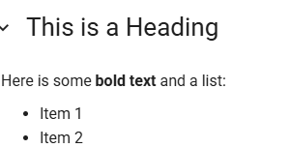

import ipywidgets as widgets

from IPython.display import display

slider = widgets.IntSlider(value=50, min=0, max=100, step=1, description='Value:')

output = widgets.Output()

def on\_value\_change(change):

    output.clear\_output()

    with output:

        print(f'Slider value is {change["new"]}')

slider.observe(on\_value\_change, names='value')

display(slider, output)

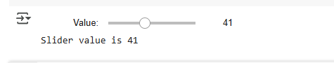

**Result:**

Thus the Setting up the python environment and libraries in Jupyter Notebook is done successfully.